Mutton, Dennis Ray (from Linked In)
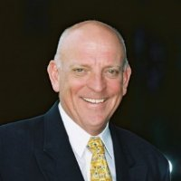

B.Sc (Hons1), forest science The Australian National University 1964 – 1967. Capicornia IAE Graduate Diploma in Management 1980 – 1981. Australian Administrative Staff College Mt Eliza Advanced Course 67, 1980.

CEO Woods and Forests 1988 – 1992 South Australia. CEO Dept Environment and Natural Resources SA 1992 – 1997 Adelaide. CEO Primary Industries and Resources SA 1997 – 2002 Adelaide. Chairman Bio Innovation SA 2001 – . Adelaide. Owner Focus on Solutions March 2002 – . Chairman Grape and Wine Research and Development Corp 2004 – 2010. Director/Treasurer Leaders Institute of South Australia 2004 – 2009. NED WPG Resources Ltd 2010 – Sydney. Deputy Chair CRC Pork Ltd November 2012 –. Adelaide. Chair Council of Rural Resesearch and Development Corporations 2010 – 2013 Adelaide. Board Member TAFE Regional Council SA June 2011 – October 2012 South Australia. CEO Woods and Forests 1988 – 1992 South Australia. CEO Dept Environment and Natural Resources SA 1992 – 1997 Adelaide. CEO Primary Industries and Resources SA 1997 – 2002 Adelaide.

